**IT Asset Management - Query Processing**

**DESCRIPTION**

**Fall 2023**

Contents

Class and Team Information 1

Problem Description 1

Conceptual Design and Logical Design 2

Designs, Queries and Sample Results 5

Original ER Diagram and Relational Schemas (25 points) 5

List of Tables, Corresponding Columns and Column Types (75 points) 6

Query 1 – Servers 7

Query 2 – Hardware Systems 7

Query 3 – Branches and Housed Servers 10

Query 4 – Asset Prices 10

Query 5 – Expired Software 11

Query 6 – Impacted branches by the expired software 13

Query 8 – Hardware systems, which have passed their warrantee periods. 14

Query 9 – Servers and connected hardware. 15

Query 10 – Servers and Branches. 16

What to Turn In 17

# Class and Team Information

CSCI 3410-Section DA, Group 1

**Team members:**

1. Alexander Schoolcraft, Team Lead
2. Lindy Ankcorn
3. Brent Gibbins
4. Dawson Jones-Fischer
5. Evan Nowicki

# Problem Description

**Write and execute queries** against the **database you will create** using the following conceptual and logical designs.

Populate your tables with a small set of appropriate and relevant data and run the queries against them. In about a week before the project deadline, I will give you my **sample dataset**, which you must use to produce the results to be submitted. Therefore, it is imperative that you develop and test your queries thoroughly with your own data set before you receive mine.

The **columns of the results** must match the sample query results I have shown in each query section.

If the **requested number of output rows** is too many to be screen captured, export the result to a CSV file first, then extract (i.e., screen shot) and include the requested number of rows in this document.

# Conceptual Design and Logical Design

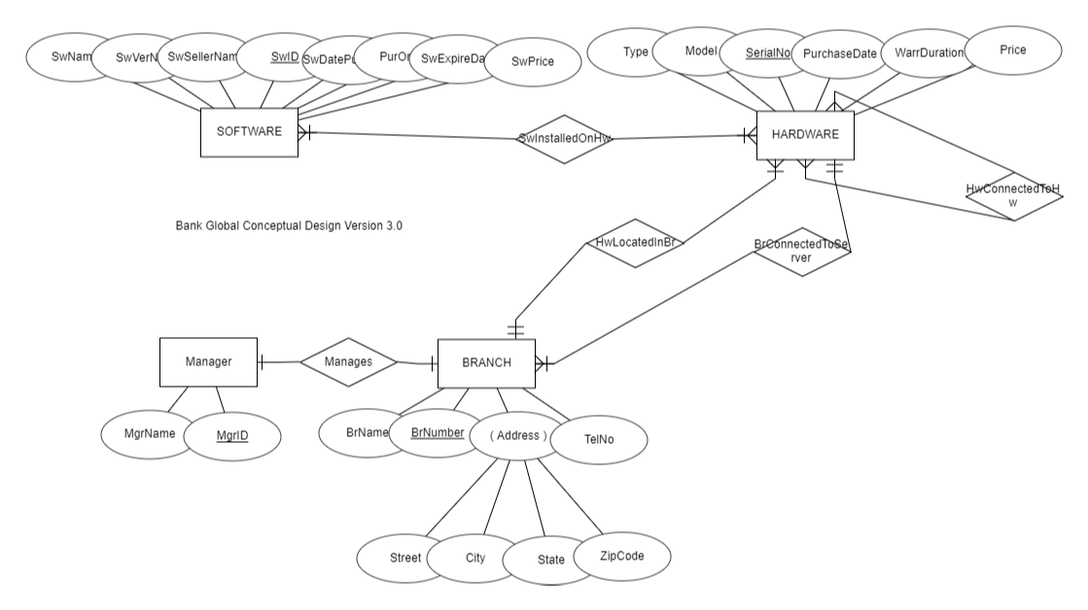

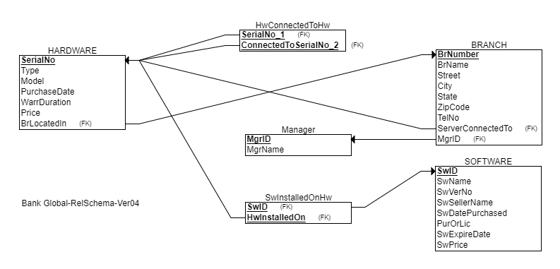

|  |  |  |
| --- | --- | --- |
|  |  |  |
|  |  |  |

# Designs, Queries and Sample Results

## Original ER Diagram and Relational Schemas (25 points)

[Insert, below, the images of your conceptual design (i.e., ER diagram) and logical design diagram (i.e., relational schema diagram), which you developed, initially, before receiving mine.]

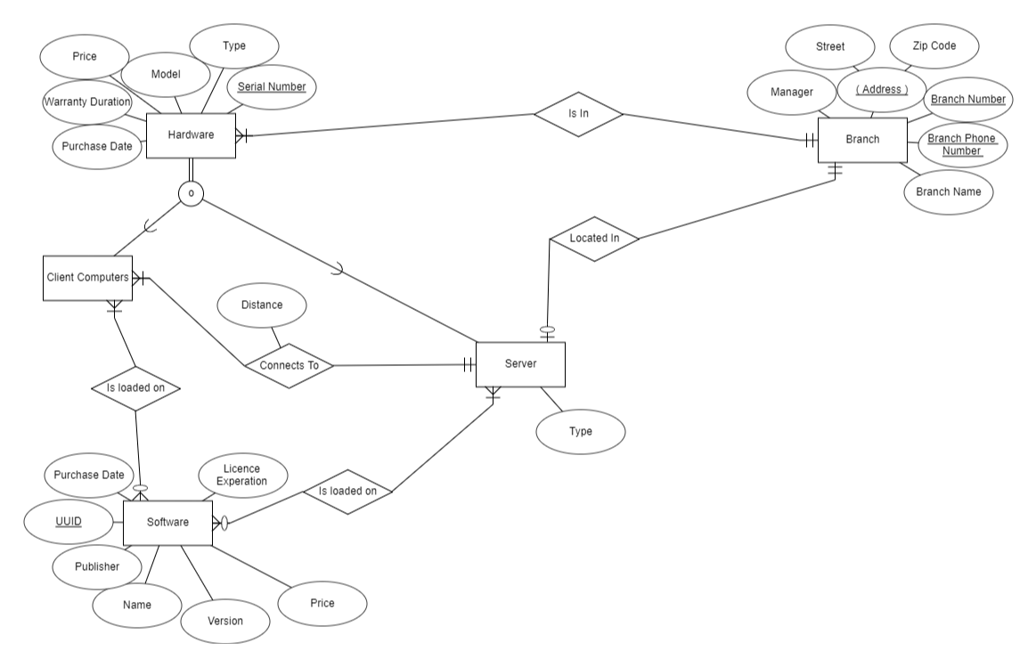

## List of Tables, Corresponding Columns and Column Types (75 points)

[Example:

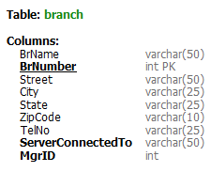]

[Similar to the above example image, insert the images of your tables below, in the ascending order of table names]

## Query 1 – Servers

**Query in English**: List the types and model numbers of all the servers. (ALL ROWS)

**Sample Query Result:**

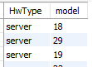

**Query in SQL:**

[Show the query statements]

**Result:**

[Show the result of the query]

## Query 2 – Hardware Systems

**Query in English**: List the branch numbers and zip codes of the branches, which house all the hardware systems (1st 50 ROWS)

**Sample Query Result:**

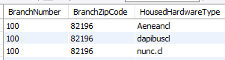

**Query in SQL:**

[Show the query statements]

**Result:**

[Show the result of the query]

## Query 3 – Branches and Housed Servers

**Query in English**: List the branch numbers and zip codes of the branches, which house the servers (ALL ROWS)

**Sample Query Result:**

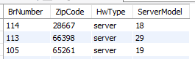

**Query in SQL:**

[Show the query statements]

**Result:**

[Show the result of the query]

## Query 4 – Asset Prices

**Query in English**: What is the count and total price of the hardware and software assets in the bank? (ONE ROW)

**Sample Query Result:**



**Query in SQL:**

[Show the query statements]



**Result:**

[Show the result of the query]



## Query 5 – Expired Software

**Query in English**:

Create a procedure called ExpiredSoftware to show the software applications, which have expired GraceDays before a TargetDate. TargetDate and GraceDays are the input parameters of the procedure.

Show the results of the following two procedure calls:

CALL ExpiredSoftware("2020-12-01", 90); -- ALL THE ROWS

CALL ExpiredSoftware("2023-09-05", 60); -- 1ST 20 ROWS

**Sample Query Result:**

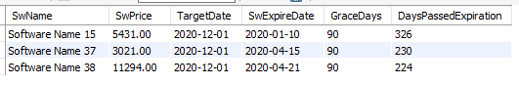

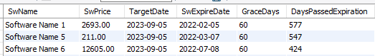

**Query in SQL:**

[Show the query statements]

**Result:**

[Show the result of the query]

## Query 6 – Impacted branches by the expired software

**Query in English**:

Create a procedure called ImpactedBranches to list the branch numbers, which are impacted by the expiring software applications. The branches will be impacted, if an expiring software is installed on a hardware system, which is either located in the branch or the branch is connected to it. In the latter case, the hardware system must be a server to which the branch is connected. TargetDate is the input parameter of the procedure. A software application is expired, if its expiration date is before the TargetDate.

Your query should sort the result in ascending order of BrNumbers.

Show the result of the following call:

CALL ImpactedBranches (“2023-01-01”); -- (1ST 20 ROWS)

**Sample Query Result:**

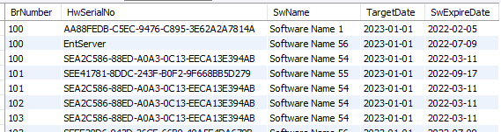

**Query in SQL:**

[Show the query statements]

**Result:**

[Show the result of the query]

## Query 8 – Hardware systems, which have passed their warrantee periods.

**Query in English**:

Show the hardware systems whose warrantees, relative to a target date, have ended. Produce the query results for each of the target dates of "2010-01-01" and "2015-01-01", respectively. (ALL ROWS)

**Sample Query Result:**



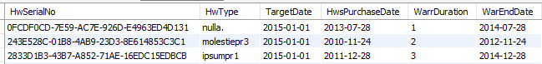

**Query in SQL:**

[Show the query statements]

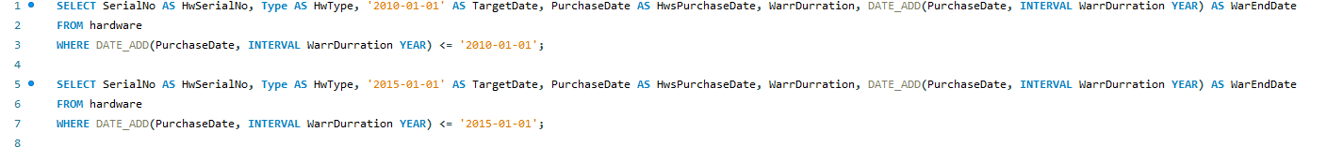

**Result:**

[Show the result of the query]



## Query 9 – Servers and connected hardware.

**Query in English**:

Show the hardware systems, which are connected to each server. Group and sort the result by the model numbers of the servers and the model numbers of the connected hardware systems, respectively (List 20 rows)

**Sample Query Result:**

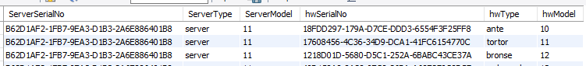

**Query in SQL:**

[Show the query statements]

**Result:**

[Show the result of the query]

## Query 10 – Servers and Branches.

**Query in English**:

For each server, show the branches connected to it. Group and sort the result by the server model number and the branch number, respectively (1ST 20 ROWS)

**Sample Query Result:**

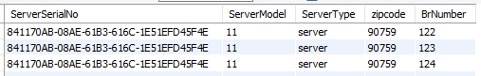

**Query in SQL:**

[Show the query statements]

**Result:**

[Show the result of the query]

# What to Turn In

1. This document, which includes your responses. Add your name to the file name after the word Fall2023-
2. One exported **self-contained file**, which contains **your team developed** database schema and data. Refer to the following YouTube video, which describes how a MySQL database file can be exported:

[MySQL Workbench Database Export and Import](https://www.youtube.com/watch?v=Jvul-wr-_Bg)

1. One exported **self-contained file**, which contains your database schema and data, based on the **dataset I gave you**.